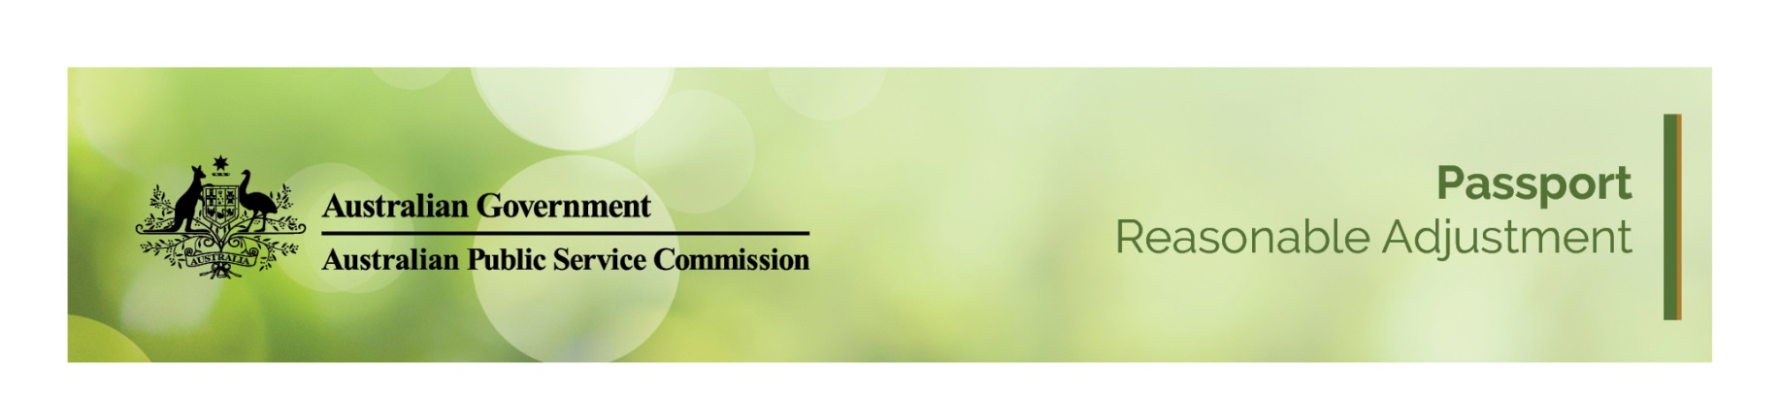
Passport Reasonable adjustment
Reasonable Adjustments Passport form is a tool for employees and supervisors/managers to document any form of assistance or adjustment that is necessary, possible and reasonable to reduce or eliminate barriers at work for a person with an injury, illness or disability. This Passport should be read in conjunction with the Reasonable Adjustment Guide and Reasonable Adjustment Passport – Managers Guide.

Instructions
Fields marked with * are mandatory, and must be completed before signing or submission.

Personal Details
Family name * | Given name *
Group name*

Adjustment Details
Workplace impacts of injury, illness, medical condition or disability *
(Example - I find it difficult to navigate through stairways and heavy doors)

Workplace adjustment requirements *
(Example - I have access to automatic doors and an elevator where possible, flexible working hours)

A disability/medical condition that needs no action, but needs to be bought to the attention of manager*
(Example - epilepsy/diabetic/mental illness)

Emergency arrangements *
(Example - I have an arrangement with the floor warden to access the elevator during building evacuation drills).

Do you require a Personal Emergency Evacuate Plan?

Other Support?

Co-worker support *
(Example - buddy arrangement set up for me so I can be assisted in the case of building evacuation)

Recommended adjustments *
(Identify below what has been recommended by a medical practitioner or workplace assessment or what you currently use. For example, ergonomic chair, speech recognition software)

Detail Adjustments * | Existing I New Requirement * | Action Required * | Comments *

Additional Comments

Workplace Assessments
List date of last ergonomic workplace assessment or Occupational Therapist assessment)
Date of last assessment (if applicable)
Date of next review (if required).

Who should be informed of these workplace adjustments *
(Example - my supervisor, case manager and/or the Floor Warden)

Signatures
Employee:

Manager:

Reasonable adjustments that require action by HR should be requested via people@apsc.gov.au
Simple requests will be actioned within ten days.
The escalation point for reasonable adjustments is the Head of Corporate.

