

Workplace Adjustment Passport

An employer’s guide to facilitate, plan and implement workplace adjustments to support employees with disability.



# Acknowledgement of Country

We acknowledge the traditional custodians of Australia and the lands upon which we live and work and pay our respects to Elders past and present. We also acknowledge the stories, traditions, and living cultures of Aboriginal and Torres Strait Islander peoples.

**Contents**

What is a workplace adjustment? 4

Free workplace adjustment resources on JobAccess Website 4

Sharing access requirements 5

What is a workplace adjustment passport? 5

What information should be included in a workplace adjustment passport ? 6

Workplace adjustment passport process 6

Privacy and confidentiality 7

Reviewing workplace adjustments 7

Other times to use the adjustment passport 7

Reasonable Adjustment Policy 7

Real life story: a passport to success 8

Sample workplace adjustment passport 11

Reasonable adjustment checklist 15

This guide helps organisations create and use a ‘Workplace Adjustment passport’ to support employees with disability. It should be read alongside the organisation’s Workplace or Reasonable Adjustment policy, if one is available.

# What is a workplace adjustment?

Workplace adjustments (also called reasonable adjustments) are changes made to help employees with disability work safely and effectively. These changes can be:

* Administrative: Changing how tasks are given or completed.
* Environmental: Making changes to the physical workspace.
* Procedural: Changing policies or work process.

Not everyone with disability needs a workplace adjustment to do their job well. However, employers can easily make simple adjustments to remove barriers to employment. Many of these adjustments are good management practices that support all employees, not only those with disability.

Providing workplace adjustments shows that an organisation is committed to inclusive andand sustainable employment for people with disability.

## Workplace Adjustment Policy

An effective Workplace Adjustment Policy should explain how adjustments are made, to meet the needs of employees with disability. ItIt should also include a checklist to help employers follow rules and meet their obligations under the Disability Discrimination Act 1992 and any relevant state law.

# Free workplace adjustment resources on JobAccess Website

* JobAccess toolkit: Start: S with the [Workplace modifications made easy](https://www.jobaccess.gov.au/stories/workplace-adjustments-made-easy) and [Getting your workplace ready section for](https://www.jobaccess.gov.au/i-am-an-employer/employer-toolkit/getting-your-workplace-ready) practical information and templates to help employers plan and implement workplace adjustments.
* [Managing your team](https://www.jobaccess.gov.au/i-am-an-employer/employer-toolkit/managing-your-team) offers tips on creating a supportive workplace.
* Conversation guide**:** [Making workplace adjustments easy, effective and equitable - A conversation guide](https://www.jobaccess.gov.au/resource/workplace-adjustment-guide): Offers tools for both employers and employees to discuss workplace adjustments.
* [Workplace Adjustment Policy template](https://www.jobaccess.gov.au/resource/reasonable-adjustment-template) and checklist: Provides a framework for employers. These can be viewed alongside [Flexible work policies](https://www.jobaccess.gov.au/stories/flexible-work-organisation).
* [Application process and guidelines for the Australian Government’s Employment Assistance Fund](https://www.jobaccess.gov.au/i-am-a-person-with-disability/looking-applying-job/government-services-help-you/funding-workplace-changes/applying-eaf): Details the application process for financial support to implement workplace adjustments.
* [Making changes for different types of disability](https://www.jobaccess.gov.au/i-am-an-employer/create-accessible-inclusive/making-changes-different-types): how you can support your employees and create a workplace that is accessible for all.
* [Career progression for people with disability](https://www.jobaccess.gov.au/resource/careerprogresspeopledisability): Provides guidance on adjustments throughout an employee’s career lifecycle.

# Sharing access requirements

You might be familiar with the term ‘disclosure’ when sharing information about disability. Instead, we recommend using the term ‘sharing access requirements’. It is an employee’s choice to share how their disability may affect their ability to do their job.

There is no legal obligation for job applicants or employees to share information about their disability with an employer, unless it:

* Affects their ability to perform the inherent requirements (also known as essential requirements) of the job
* Affects their safety, or
* Affects the safety of their co-workers.

Some people may choose not to share this information because they fear discrimination, worry about being treated unfairly, or think their disability won’t affect their work.

Having a clear Workplace Adjustment policy that everyone knows about can help employees feel comfortable to share their access requirements. Some might share this information before starting the job, while others might wait until after their probation period, or until the barrier impacts their job.

You do not need to know all the details of an employee’s condition. Focus on understanding the symptoms they face at work, how these might affect their ability to perform task, and what adjustments can be made to help them work effectively and safely.

# What is a workplace adjustment passport?

A workplace adjustment passport is a document that list the adjustments anan employee needs to do their job. It’s a helpful tool for both employees and employers. The three main purposes passport are:

* **Facilitate to make adjustment easy to transfer**:If an employee changes teams or departments, they won’t need to discuss their requirements again.
* **Structure or guide a conversation:** It helps the employer and employee talk about the adjustments the need.
* **Plan** **for when the employee is unwell:** If an employee’s disability is episodic or changes, the passport helps plan what to do (for example, if the employee has a seizure).

# What information should be included in a workplace adjustment passport?

Employees don’t need to share detailed information about their disability. They only need to share how it may affect ability their ability to perform a key task. The focus should be on identifying the workplace adjustment needed. The passport belongs to the employee can be updated as required.

# Workplace adjustment passport process

Making workplace adjustments starts with understanding the basic task of the of a role:

* **Understand the job requirements:** This can be done by reviewing the job and understanding what’s needed to do the job. Learn more with our [Job analysis and customisation guide](https://www.jobaccess.gov.au/resource/job-analysis-and-customisation).
* **Have a discussion:** The employee and manager should talk about what adjustments are needed and agree on them. JobAccess’ [Conversation guide on workplace adjustments](https://www.jobaccess.gov.au/resource/workplace-adjustment-guide) is a great resource to start the discussion.
* **Document the agreed adjustments:** Once agreed, the adjustments should be written down in the workplace adjustment passport.
* **Sign the passport:** Both the employee and manager should sign it to confirm what actions are needed For example, who is responsible for maintaining equipment or who owns the property in the event the employee leaves the organisation.

## Managers are responsible for:

* Talking about job requirements and adjustments with the employee.
* Helping the employee their do their best, despite illness, injury or disability.
* Keeping the employee’s information private
* Supporting employees to know their rights and responsibilities about workplace adjustments.

## Employees are responsible for:

* Letting their manager if they need adjustments in the workplace
* Talking with their manager about the adjustments
* Giving the information in the passport
* Taking part in formal assessments ((for example a GP, psychiatrist, psychologist or occupational therapist) when asked.

# Privacy and confidentiality

To encourage employees to be open with you about disability, reassure them that information will be handled appropriately.

Sometimes, you may need to share an employee’s disability with others in the organisation (for example, staff in the IT department to set up equipment), However, you must get written consent from the employee first.

It is important to remember that you are required to protect the employee’s right to privacy. Failing to protect confidential personal information in relation to a person’s disability could lead to discrimination or breaches to privacy.

# Reviewing workplace adjustments

Schedule a time to review the workplace adjustments with the employee and check If they are working well. For example, does the employee need more training with the technology? Does the system need to be updated?

This is also a good chance to get feedback on the employee’s experience with the workplace adjustment passport and see if any changes can be made to improve. performance oror safety.

# Other times to use the adjustment passport

The passport can be used in different situations, such as:

* When an employee starts training or takes on new responsibilities.
* When an employee moves to a new department or team.

# Reasonable Adjustment Policy

A Reasonable Adjustment (or Workplace Adjustment) Policy covers adjustments in all parts of employment. It helps attract a wider range of candidates and keeps current employees who may develop disability.

The JobAccess website offers a free **Reasonable Adjustment Policy template** ([PDF copy](https://www.jobaccess.gov.au/sites/default/files/documents/2024-11/5491-32-reasonable-adjustment.pdf) and [Word copy](https://www.jobaccess.gov.au/sites/default/files/documents/2024-11/5491-32-reasonable-adjustment.docx)) and a **Reasonable Adjustment Policy checklist** ([PDF copy](https://www.jobaccess.gov.au/sites/default/files/documents/2024-12/7821-52-reasonable-adjustment.pdf) and [Word copy](https://www.jobaccess.gov.au/sites/default/files/documents/2024-12/7821-52-reasonable-adjustment.docx)) for employers to refer to and adapt to their organisation.

# Real life story: A passport to success

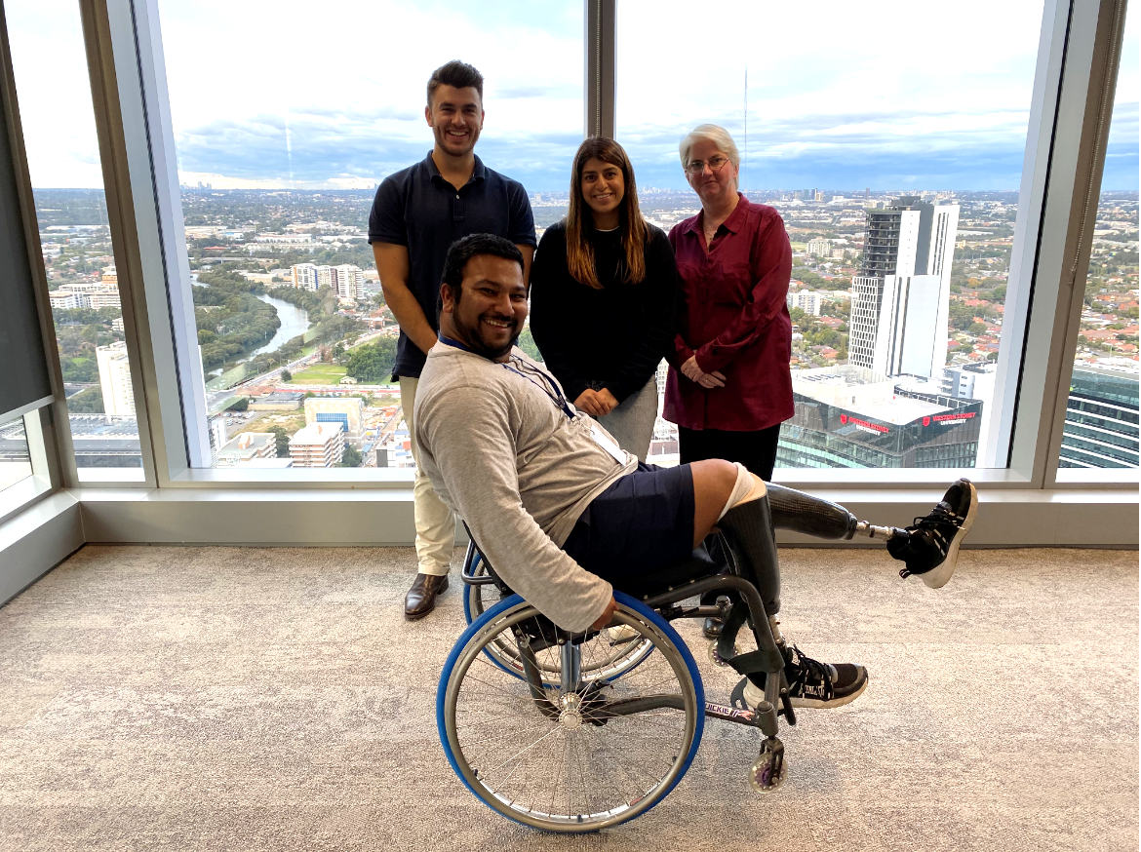Image: From left to right (back) - Alex Previtera, PJ Hothi, Ann-Marie Mahony. Front - Dwayne Fernandes.

Starting a new job can be difficult, but for Dwayne Fernandes at the Department of Planning, Industry and Environment, It meant adjusting to both a new role and a new disability. With the help of a workplace adjustment passport, he was able to get straight to work and feel valued as part of the team.

Dwayne works as a Diversity and Inclusion Partner with the Department of Planning, Industry and Environment (DPIE), where his job involves working with all part of the business to improve diversity engaging with executives and other managers.

“I am a person with two false legs but have never required adjustments in the workplace. However, within the first week of joining DPIE, a small wound on old scar tissue rendered me unable to use my prosthetics to walk and run. I went from having high mobility to low mobility, having to use my old wheelchair, and work remotely. This is where my workplace adjustment passport journey begins,” explained Dwayne.

On his first day, Dwayne met his manager and the team, collected his laptop and started working remotely. Eager to join the team in the office, he used DPIE’s workplace adjustment passport process. The online system asked about his disability, suggested adjustments, and outlined the necessary steps for approval.

“At 11:07 am I filled out the online form and requested two adjustments, one major and one minor, being ongoing remote working and access to the office car park. By 1:19 pm I had confirmation that the major adjustment has been approved and implemented and by 3:15 pm the minor adjustments has been put in place. My response was wow, just wow - a formal process of workplace adjustment that is conducted with dignity and efficiency,” shared Dwayne.

Tiffany Auvaa (Manager WHS Projects), Alex Previtera (WHS Coordinator), PJ Hothi (Diversity & Inclusion Programs Manager) and Ann-Marie Mahony (Disability Employee Network Chair and Diversity Officer) were the working group championing and implementing the new workplace adjustments passport online portal process.

“One of the department’s key objectives to achieve in our Disability Inclusion Action Plan (DIAP) was to implement a workplace adjustment process. We wanted to make sure when rolling this out we had a world class approach, so we worked in collaboration with Tiffany and Alex to help deliver a solution to meet employee needs in looking for any type of adjustment due to physical attributes, disability, injury or illness, including both temporary and permanent conditions. Collaboration was key for success. We consulted with the National Disability Recruitment Coordinator (NDRC), the DPIE disability community, our Harmony Council, People Partners and the Australian Disability Network to make sure we had universal consultation,” said PJ.

“It is led by and focuses on the individual, with an automated online process that produces a workplace adjustment passport they can take anywhere within the organisation. This means they do not need to repeat the process of applying for their adjustments, they only need to do it once or when there are required updates. The person requiring the adjustment is in complete control of it and how it is managed throughout their employment,” Alex states.

“Another key feature of the online portal is that the application goes directly to the Work Health and Safety team for action. This means decision-making comes from the individual in direct consultation with subject matter experts and has resulted in rapid implementation of workplace adjustments. It also takes the pressure off the individual’s manager in terms of a task they may not be familiar with and allows them more time to focus on their day-to-day responsibilities,” said Tiffany.

As part of their ongoing commitment to including people with disability , DPIE is working with the [National Disability Recruitment Coordinator (NDRC)](https://www.jobaccess.gov.au/employers/about-national-disability-recruitment-coordinator), aa service from JobAccess. The NDRC helps employers across Australia feel more confident in hiring people with disability by offering free, tailored 12-month support. An NDRC Professional Adviser works directly with each employer, to identify and remove barriers in the workplace and promote more inclusive practices.

“By partnering with the NDRC and the Australian Disability Network, we have enabled a safe and accessible workplace and are therefore able to attract a wider audience of people with disability,” explained PJ.

Ann-Marie sees many advantages in having a workplace adjustments system. She also offers this advice to employers who are thinking about setting up a similar project.

“Consultation is crucial. Make sure you consult with all users and listen to your employee networks. In our case, they shaped the guidelines which outline everyone’s responsibilities. Communication is also important. Make sure the process is simplified, in plain English and there is a good communications plan and educational roll out. Most importantly, find a system and process that works for you and your people, and that the decision-maker of the adjustment is the person with disability and the subject matter experts,” shared Ann-Marie.

According to Dwayne, while the recent wound injury may have affected his personal life, it did not affect his professional one. “When you acquire a disability, your personal life can be in disarray, so it’s fantastic to have a system to ensure career consistency and progression. My day-to-day job wasn’t affected.

“My advice to employers is that if you want to retain quality and engaged staff, you need to get these things right. Having this support to seamlessly manage the change (and within my very first week with DPIE) made me feel valued as an employee,” said Dwayne.

# Sample workplace adjustment passport

## Personal details

|  | Employee | Supervisor/manager |
| --- | --- | --- |
| Name |  |  |
| Job title |  |  |
| Location |  |  |

## Employment support provider details

|  |  |
| --- | --- |
| Provider name |  |
| Consultant |  |
| Alternative support contact |  |
| Address |  |
| Phone number |  |
| Email |  |
| Website |  |

## Position description and job requirements

|  |  |
| --- | --- |
| Date position description reviewed |  |
| Tasks requiring adjustment |  |

## Details of employee’s circumstances

How does your disability impact you at work?

Example: I have had injuries to my knee. I find it difficult to navigate through stairways and heavy doors.

|  |
| --- |
|  |

## What are your workplace adjustment requirements?

Example: I need a larger computer screen and zooming software to perform word processing tasks.

|  |
| --- |
|  |

## Are emergency or safety arrangements needed?

Example: As I require ramp access for my wheelchair, I require ramp access when I visit clients for safe access to buildings.

|  |
| --- |
|  |

Note: Employees who may need assistance during an evacuation should complete a Personal Emergency Evacuation Plan (PEEP) form

## Do you need co-worker support?

Example: I need co-workers to face me when they speak as I lip read.

|  |
| --- |
|  |

## Is there any other support you need?

|  |
| --- |
|  |

## Induction or onboarding – the early days of employment

| Action – describe what should happen | Person and team responsible | How often and for how long |
| --- | --- | --- |
| Example: Employee will do work health and safety training | Employee | In first week, then annually |
| Example: Employer will provide the following equipment:  1. Item one  2. Item two | Employer | Within first week, then ongoing as required |
|  |  |  |
|  |  |  |
|  |  |  |
|  |  |  |

## Probation period

|  |  |  |
| --- | --- | --- |
| Action – describe what should happen | Person and team responsible | How often and for how long |
| Example: Employee will learn the job tasks listed: 1. First task (list the duties of the task)  2. Second task (list the duties of the task) | Employer to assist employee | In first 6 months |
|  |  |  |
|  |  |  |
|  |  |  |
|  |  |  |
|  |  |  |

## Retention and career development

|  |  |  |
| --- | --- | --- |
| Action – describe what should happen | Person and team responsible | How often and for how long |
| Example: Employer will identify learning possibilities | Employer | Regularly to develop employee |
|  |  |  |
|  |  |  |
|  |  |  |
|  |  |  |
|  |  |  |

## Monitor and review

|  |  |
| --- | --- |
| Date adjustments identified and agreed to |  |
| Date adjustments implemented |  |
| Date of review |  |

## Signatures

|  |  |
| --- | --- |
| Employment support provider (name) |  |
| Employee (name) |  |
| Employer (name) |  |

# Reasonable adjustment checklist

Use this checklist to help operationalise the reasonable adjustment process

| Action | Start date | Completed date | Responsible |
| --- | --- | --- | --- |
| Request for reasonable adjustment received |  |  |  |
| Key personnel to meet with employee to clarify specific needs |  |  |  |
| Additional information requested (if required) |  |  |  |
| Medical evidence requested  (if required). This should be relevant to the inherent requirements of the role. |  |  |  |
| Detailed and signed request sent to (nominated department / person) |  |  |  |
| Reasonable adjustment managed internally, and key staff advised (adjustment could include: any job redesign required, flexible hours or additional training to be offered) |  |  |  |
| Cost estimates made for workplace modifications |  |  |  |
| [An](http://An) application for the Employment Assistance Fund (EAF) has been submitted through [www.jobaccess.gov.au](http://www.jobaccess.gov.au) |  |  |  |
| Workplace assessment arranged through the EAF (if required – JobAccess will advise) |  |  |  |
| Equipment for workplace modification ordered |  |  |  |
| Installation of equipment booked, and key personnel advised |  |  |  |
| Reasonable adjustment / workplace modification fully implemented |  |  |  |
| Feedback requested from employee on effectiveness of adjustment |  |  |  |
| Request for reasonable adjustment finalised and filed in employee’s personnel file |  |  |  |
| Copy of completed request sent to (insert department / person) |  |  |  |