# Understanding workplace attitudes toward disability

Results from national research commissioned by JobAccess



December 2023

### Acknowledgement of Country

We acknowledge the traditional custodians of Australia and the lands upon which we live and work and pay our respects to Elders past and present. We acknowledge the stories, traditions, and living cultures of Aboriginal and Torres Strait Islander peoples on this land.

### Introduction

Improving accessibility is vital to the socio-economic participation of 4.4 million Australians with disability. This includes participation in day-to-day life, employment and the community.

Just over 50% of people with disability are in the labour force compared with 84% of those without disability. This gap of over 30% has remained unchanged for nearly 20 years. Currently, the unemployment rate for people with disability is 10.3%, more than double than that for people without disability.

A range of attitudinal, environmental and systemic barriers contribute to the disability employment gap. Some of the barriers include lack of exposure and limited awareness of disability, inaccessible workplaces, inequitable employment practices, and poor knowledge of supports available.

One of the most powerful tools in an employer’s toolkit to support people with disability is organising workplace adjustments. While not all people with disability require adjustments at work, knowing how to provide adjustments can help employers attract, employ and retain an often-overlooked talent pool.

JobAccess conducted its **first national survey** in 2021 to gauge insights into the awareness of disability and workplace adjustments among Australians. This year, JobAccess embarked on the same survey to understand the current state of disability confidence and awareness within Australian workplaces.

The ‘Understanding workplace attitudes toward disability’ survey was conducted by Antenna Insights on behalf of JobAccess in September 2023. Over 1,000 Australians were surveyed, with the nationally representative sample weighted by age and gender to the 2021 ABS Census to ensure accurate representation.

Sixty six per cent of survey respondents were employed in full time and part time jobs, while the remainder included people who are retired, having caring responsibilities or unemployed. Forty nine percent of the respondents were involved in making final hiring decisions within their organisation, either themselves or in consultation with others.

This research highlights results from the 2023 survey and includes a wide range of free resources and services employers can access to support people with disability at work.

### Part 1: Workplace adjustments

Have you heard of workplace adjustments?

* 60% of respondents haven’t heard of workplace adjustments. Awareness has improved by 10% since 2021.
* 59% of people with disability are not aware of workplace adjustments
* 2 in 5 people see workplace adjustments as something that is easy
* 37% benefitted from a workplace adjustment

Workplace adjustments are administrative, environmental, or procedural changes that enable people with disability to have equitable employment opportunity and work effectively and comfortably.

[**This video in the JobAccess Employer Toolkit**](https://www.jobaccess.gov.au/stories/workplace-modification-made-easy) explores the different supports and services available through JobAccess to make adjustments in the workplace.

The definition of 'workplace adjustments' was provided to all participants, who were aware or unaware of the concept, and they responded to the following survey questions accordingly.



Who is responsible for making workplace adjustments?

Most respondents believe that employers are responsible for workplace adjustments.

* 63% see the employer as responsible for the cost of workplace adjustments
* 69% agree that they would be comfortable to ask for a workplace adjustment
* 57% agree that they would be more likely to choose to work for an employer who asked about workplace adjustments as part of the recruitment process
* 76% agree that making workplace adjustments for a person with disability is an important part of a manager’s job

Under the Disability Discrimination Act 1992 (DDA), if an employer is aware of an employee’s disability, they must provide what is regarded [**‘reasonable adjustment’**](https://www.jobaccess.gov.au/i-am-an-employer/know-rights-responsibilities/guidelines-reasonable-adjustment) — also known as workplace adjustment — to support the needs of the employee.

What is the cost of making workplace adjustments?

More than a third of respondents assume making workplace adjustments involves significant cost.

* 40% estimate the cost of workplace adjustments to be significant
* Survey respondents aged 18 years and older assume an average cost of workplace adjustments to be $6,800
* Employed survey respondents (15 to 64 years), i.e., working adults assume a higher average cost of workplace adjustments, at $8,040

The majority of workplace adjustments are low cost and some changes, such as providing flexible working hours, involve no cost at all and benefit all employees, not just those living with disability.

Have you ever benefited from a workplace adjustment?  
(e.g., flexibility of hours or accessible equipment)

* Nearly 40% of respondents benefited from workplace adjustments
* 29% of respondents in our research identified as living with disability or caring for someone with disability. However, more respondents believe they have benefited from a workplace adjustment.

Workplace adjustments can help all employees, with or without disability.

What type of adjustments have you or the person you care for benefitted from?

* Over 60% of respondents benefitted from flexible working hours and flexible work arrangements, such as working from home or remote work

People have also benefitted from extra training and mentoring at work, having access to assistive technology (software or equipment), as well as support or counselling in the workplace

How are workplace adjustments beneficial to you or the person you care for?

Accessing workplace adjustments reap wide-ranging benefits for people with disability and their carers.

* 55% of respondents say it helped them maintain their job
* 44% say it led to an increase in productivity
* 39% believe it helped increase job satisfaction
* 1 in 3 say it increased job sustainability

How confident are you in making workplace adjustments?

* 3 in 10 people say they know how to arrange workplace adjustments for employees with disability
* 29% agree that talking about workplace adjustments with an employee is outside their comfort zone
* 72% are unsure or don’t know how to arrange workplace adjustments for an employee with disability

Some workplace adjustments can be easy to implement, such as flexible work arrangements.

People with disability, employers and service providers can contact JobAccess on **1800 464 800** to organise work-related equipment, modifications, and services.

They may be eligible to receive financial assistance to cover the costs of making such adjustments through the Australian Government’s [**Employment Assistance Fund (EAF).**](https://www.jobaccess.gov.au/i-am-a-person-with-disability/looking-applying-job/government-services-help-you/funding-workplace-changes)

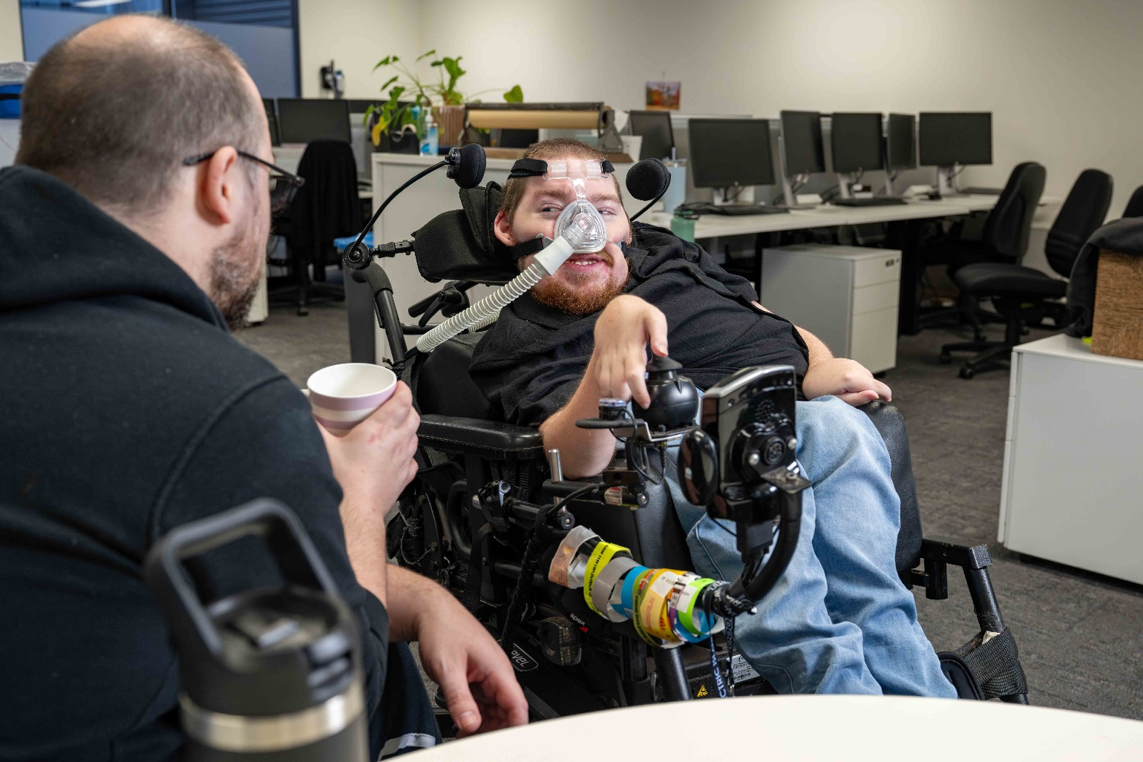

### Part 2: Disability and the workplace

Getting outside your comfort zone and gaining exposure

* 7 in 10 agree that gaining exposure to disability in the workplace would build confidence
* 1 in 5 say the fear of saying or doing the wrong thing would prevent them from employing a person with disability

Supporting employees with disability at each stage

* More than 80% say young people with disability deserve extra support to get their first job
* 71% agree that disability impacts a person’s chance of promotion

Taking active steps to promote disability employment

* Nearly 8 in 10 say it’s an employer’s responsibility to ensure a workplace is accessible for everyone
* 85% believe living with disability makes it harder to find a job
* 70% say organisations have a duty to employ a diverse workforce
* 3 in 5 agree that employers should be actively trying to employ people with disability
* Nearly 60% say they would likely choose to work for an employer who asks candidates about workplace adjustments as part of the recruitment process

### A person in a Hi-Viz top holding a hose cleaning a garage bin

### Next steps: Start your disability confidence journey with JobAccess

JobAccess has a range of services to support employers and employees with disability in the workplace.

1. Contact our national helpline 1800 464 800 or visit the [**JobAccess Employer Toolkit.**](https://www.jobaccess.gov.au/i-am-an-employer/employer-toolkit)

Our team of front-line professionals provide free, confidential and expert advice on matters relating to disability employment. The JobAccess Employer Toolkit includes a series of bite-sized videos and downloadable resources on attracting, recruiting and supporting employees with disability in the workplace.

1. Access expert advice and financial support for [**workplace adjustments.**](https://www.jobaccess.gov.au/stories/workplace-modification-made-easy)

The JobAccess team includes a range of field experts, including allied health professionals, who offer tailored advice to employers and employees from the first point of contact.

1. The [**National Disability Recruitment Coordinator (NDRC)**](https://www.jobaccess.gov.au/i-am-an-employer/hire-someone-disability/help-recruit-and-hire-people/partnering-recruitment) is JobAccess' employer engagement team. The NDRC offers **free, tailored partnerships** to larger employers with the intent to build their disability confidence and capability to attract, employ and sustain people with disability.

Having partnered with over 430 larger organisations across the public and private sector, the NDRC has the expertise and resources to guide your disability inclusion efforts.

### A person working at desk in an office space

### About JobAccess

[JobAccess](https://www.jobaccess.gov.au/employers/about-national-disability-recruitment-coordinator) is a free Australian Government service that offers expert advice, practical resources and good practice strategies — on matters ranging from workplace adjustments to building employer confidence — to drive disability employment.

This easy-to-use, one-stop service provides holistic advice, navigational support and tailored solutions for all people with disability, employers and service providers.

JobAccess services are designed to remove barriers to sustainable employment for people with disability. These services are delivered by a team of allied health professionals and disability employment experts that include people with lived experience and carers who listen, advise and support by keeping the individual and employer in focus.

JobAccess is recognised internationally for its innovative approach to disability employment. The United Nations Public Service Award and Essl Foundation’s [**Zero Project initiative**](https://www.jobaccess.gov.au/stories/zero-project-conference-2025) have recognised JobAccess for improving the delivery of services and innovative policies, respectively.