Employment Assistance Fund (EAF)

Online Application – Instructions

This guide provides step-by-step instructions on how to apply for the Employment Assistance Fund (EAF) online via the JobAccess Secure page.
If you need Auslan interpreting, workplace modifications/equipment or other services and meet the eligibility criteria, you can apply online for the Employment Assistance Fund (EAF). Read through EAF Guidelines, which details information about who is eligible, how the application process works and the evidence you need to support your application and reimbursement.
Please do not order or purchase any items prior to receiving written approval, as JobAccess is unable to backdate payments.

Frequently Asked Questions?
Any questions you may have around applying for the Employment Assistance Fund may be answered through the following webpage.
Applying for the Employment Assistance Fund | Job Access
The JobAccess team is able to assist with queries or questions by contacting 1800 464 800 or emailing jobaccess@genu.org.au.
If you are deaf or hard of hearing or have a speech impairment, you can call JobAccess via National Relay Service (NRS) .
If you need in interpreter, please use The Translating and Interpreting Service (TIS National

Accessing the Secure Application site
Go to the JobAccess home page.

- Click on “EAF/SWS Login” on the top left-hand side of the JobAccess Home page.

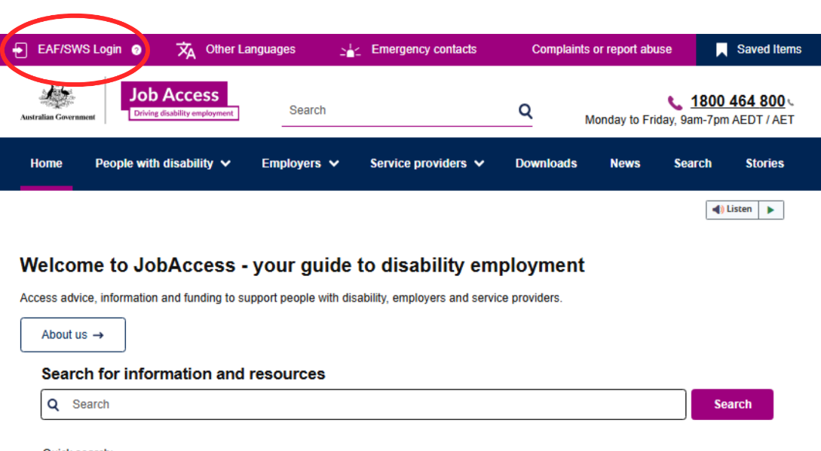

- This will display the JobAccess Secure page.

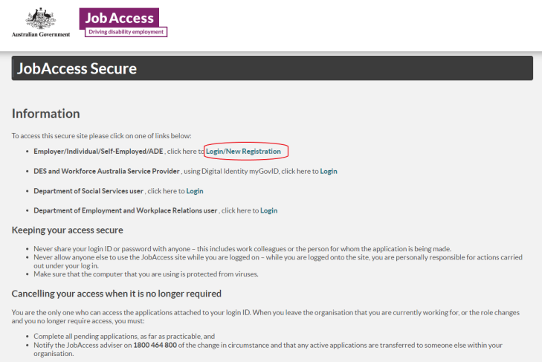

Existing users
If you have previouly made an application with JobAccess using your myGov account, click ‘Sign-in with myGov. Sign in with your myGov sign in details and it will take you through to the JobAccess secure website. If you receive an error saying that you are not authroised to use this site, you need to register as a new user.
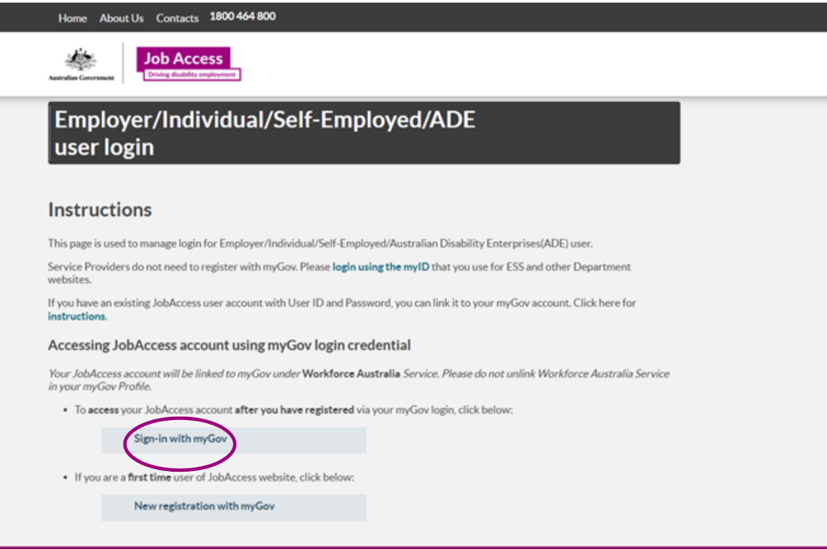

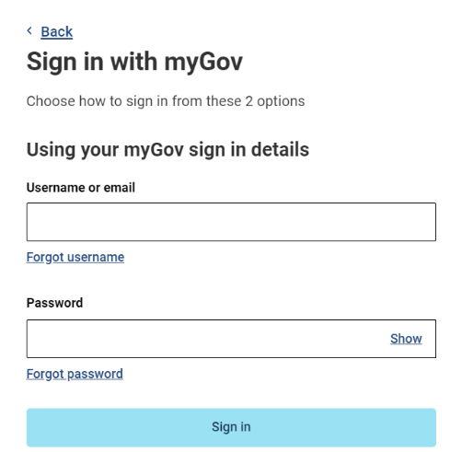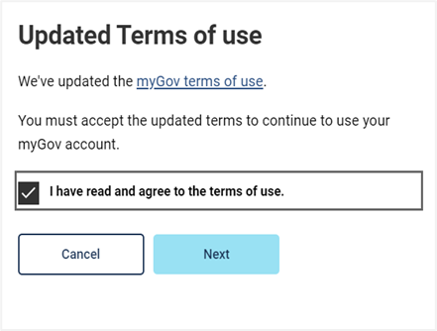

New User
If you have not previously applied for EAF online using your myGov account, select the ‘New registration with myGov’.
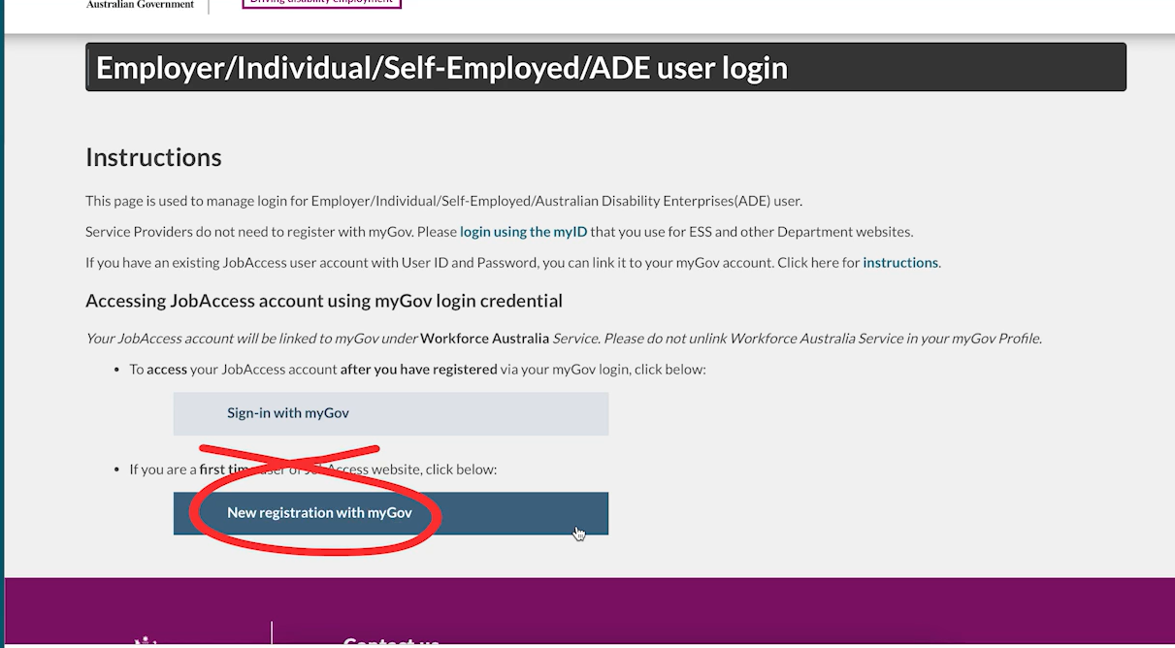
On the next screen you need to:
- Select user type from one of the following groups:
  - Australian Disability Enterprises
  - Individual or Employee
  - Self-Employed
  - Employer
- Then click on ‘Register with myGov’ button
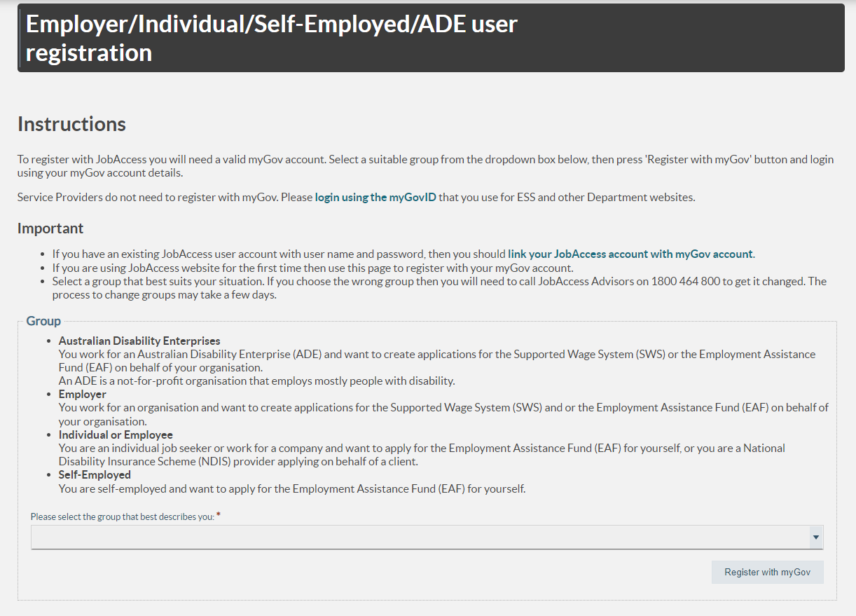
- You will be re-directed to the myGov login screen to enter your myGov username and password. Accept the myGov terms of use.
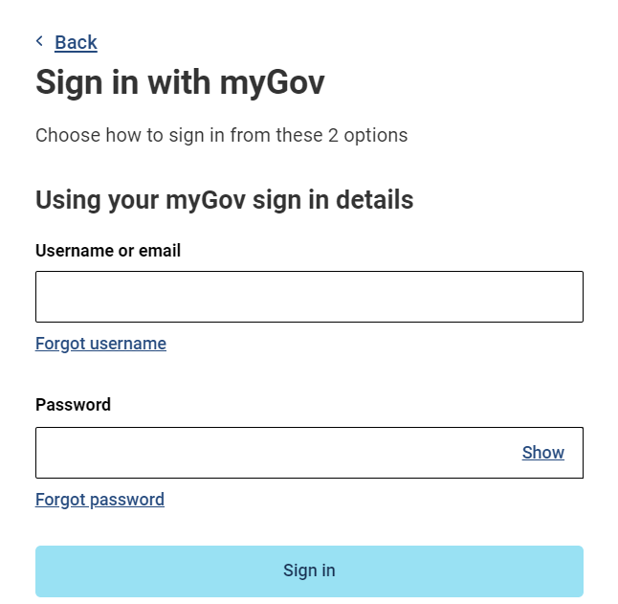 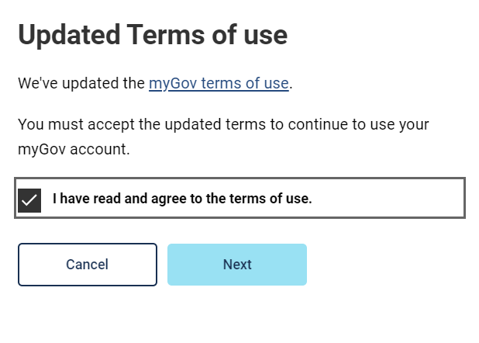
Blue arrow

- You will then be re-directed to the Department of Employment and Workplace Relations’ eSAM page to accept the ‘User Security Declaration Acceptance’ form and complete the registration.
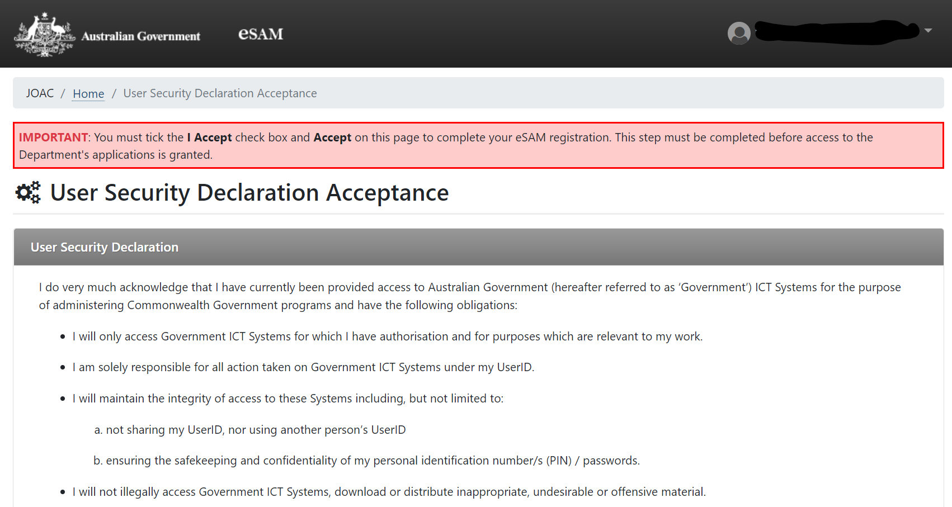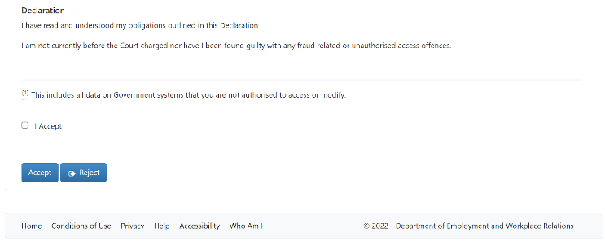
- After accepting the declaration, the registration is completed, and you are now on DEWR’s eSAM page.

- Click on the JobAccess Secure link from this page which will re-direct you to the login screen.

- You can then login to the JobAccess website just by using the ‘Sign-in with myGov’ button.

Lodging an application
- After reading the Privacy Notice, click on the “Proceed” button to start the application.
- After you have logged in and agreed to the Privacy Notice, the Welcome Page will display.
- Individuals (self-employed/employees), Employers, ADEs, or Service Providers can lodge an EAF application.

- Click on ‘Start New EAF application’.

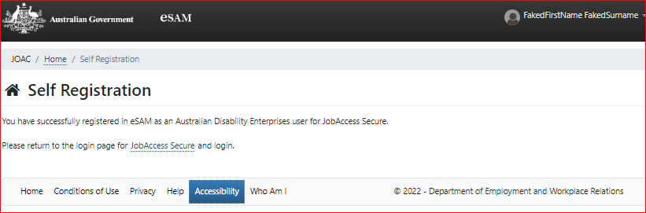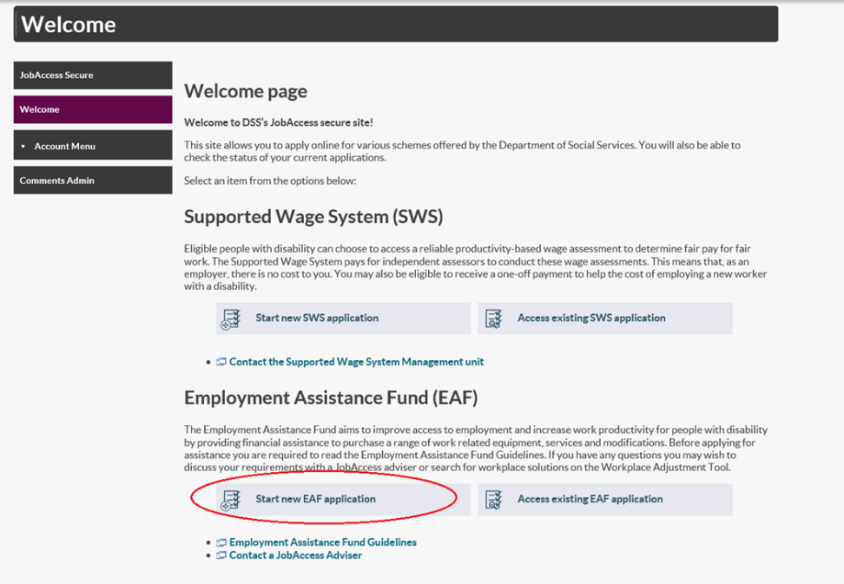

- Select who will be making the application from the drop-down list and then click next at the bottom on the page. 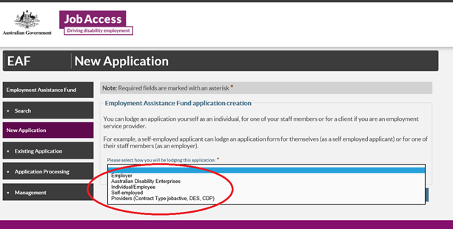

- The sites terms and conditions will display.
- You must tick the box at the bottom of the page and then click submit to proceed.
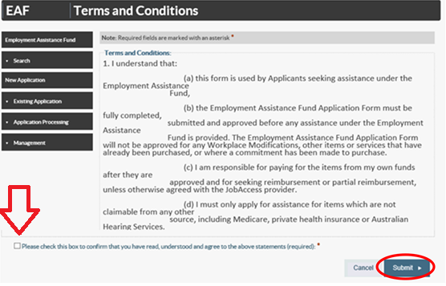

Application form

- Note: All fields marked with an asterisk* are mandatory.
- There are five tabs to the online application, and you need to complete all five steps – use the ‘Previous’ and ‘Next’ buttons to navigate through the application tabs.
- Your EAF Application ID number will display at the top right corner.

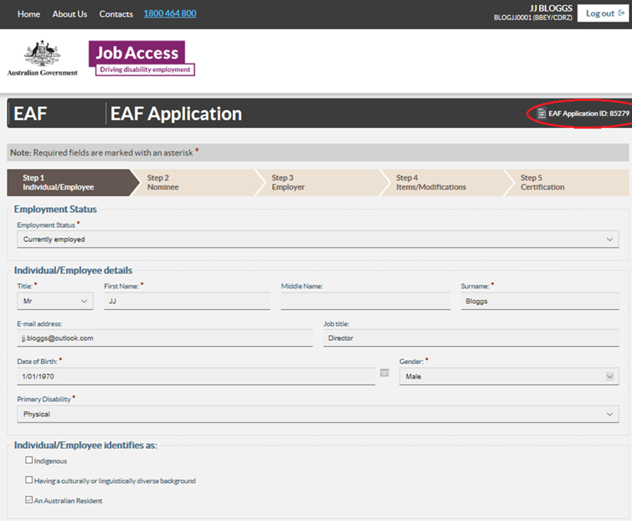

- Step 1 – ‘Individual / Employee’. Fill in the employee’s details like full name, contact details and home address. If they have a different postal address, please untick and put the postal address. Otherwise leave it.

- Step 2 – ‘Nominee’. Nominee. If someone is acting on behalf of the employee. Select ‘Yes’ and complete all fields. Otherwise, select ‘No’ and then select ‘Next’. Please note an employer contact is not considered a nominee, this will be completed at the next step.

- Step 3 – ‘Employer’. fill in theemployers’ details. To look up an employer's ABN go to www.abr.business.gov.au. The employer contact should be a line manager, team leader, or HR representative. JobAccess will send an Evidence of Employment form for the employer to fill out and confirm employment. statusSelect ‘Next’.

- Step 4 – ‘Items / Modification’. To add items, select ‘Add item’. Item Type if you are not applying for Auslan interpreting services or training, then select ‘Other’.

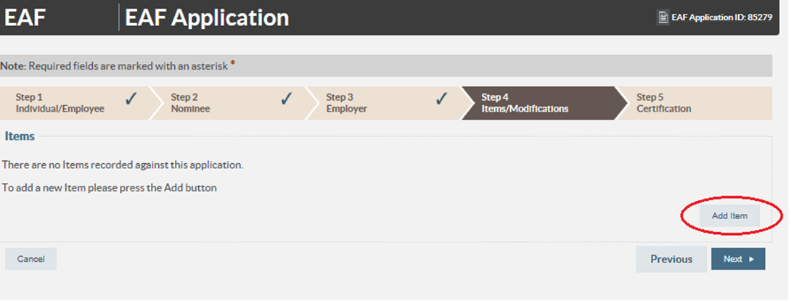
- Select the relevant item under ‘Item Type’
- Select ‘Other’ for Workplace Modifications and under ‘description’ type in the description of the item.
- If you are unsure what to type enter “to be determined” and go to the next tab.
- Under ‘Item Cost’ enter the cost of the item, or if you are unsure enter $0.00.
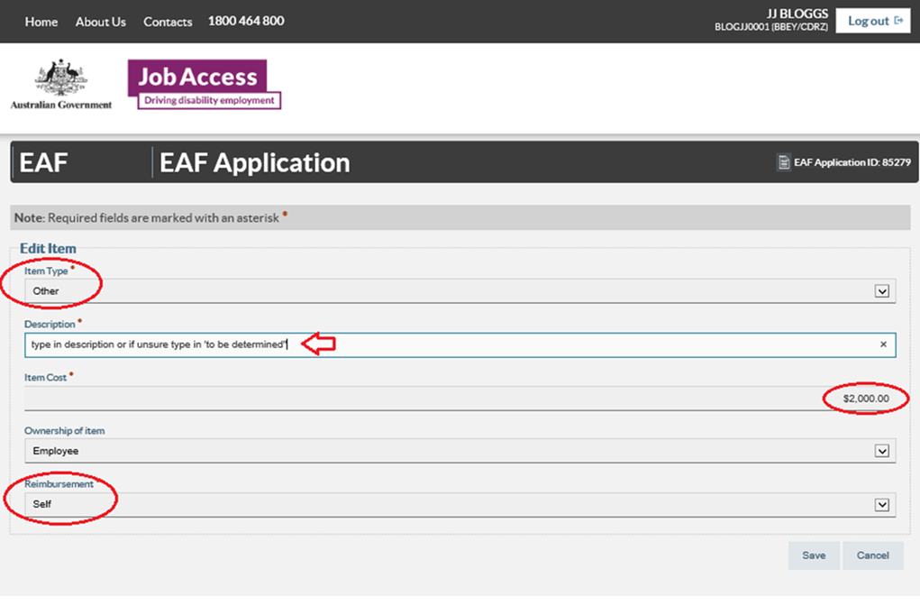

- Under ‘Ownership’ select the owner of the item. The owner is generally always the individual/employee with disability, unless the funding is for a building modification or by agreement with all parties).
- Under ‘Reimbursement’ select who will be paying for the item, should your application be approved. This is who JobAccess will reimburse the funds to following proof of purchase.
- Click ‘Save’. If you need to add another item, click ‘Add Item’. If not click ‘Next’ to proceed to Step 5, ‘Certification’.
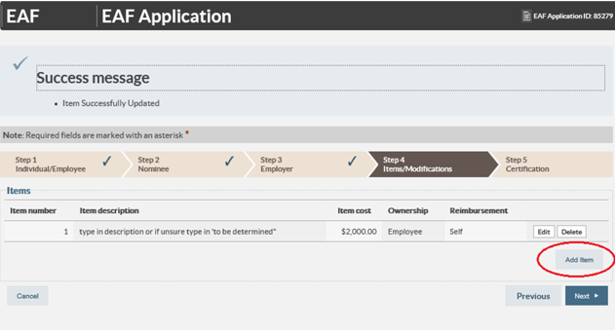
- Step 5 - ‘Certification’. Read the certification text and tick the box at the bottom of the page to confirm you have read, understood, and agreed the statement. Then click ‘submit’.

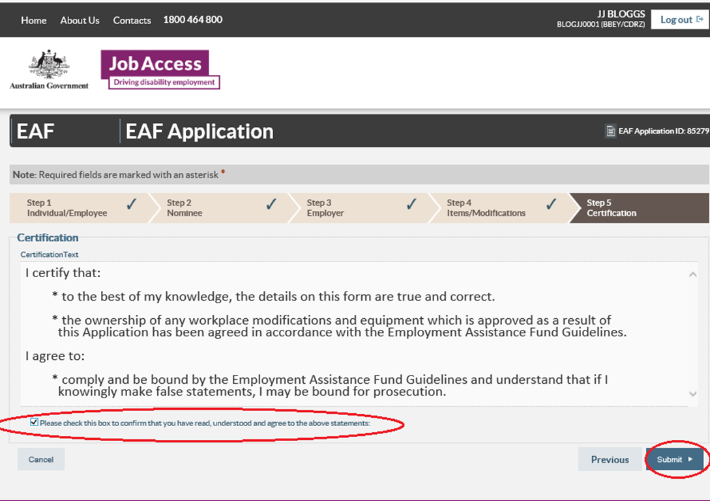
JobAccess will process the application and contact you as soon as possible. To check on current processing times please call 1800 464 800 or email jobaccess@genu.org.au
If you do not receive a ‘Success message’ with an application ID number, your application did not save correctly
Please contact, JobAccess on 1800 464 800 or email jobaccess@genu.org.au.
If you are deaf or have a hearing or speech impairment, you can JobAccess via National Relay Service (NRS).
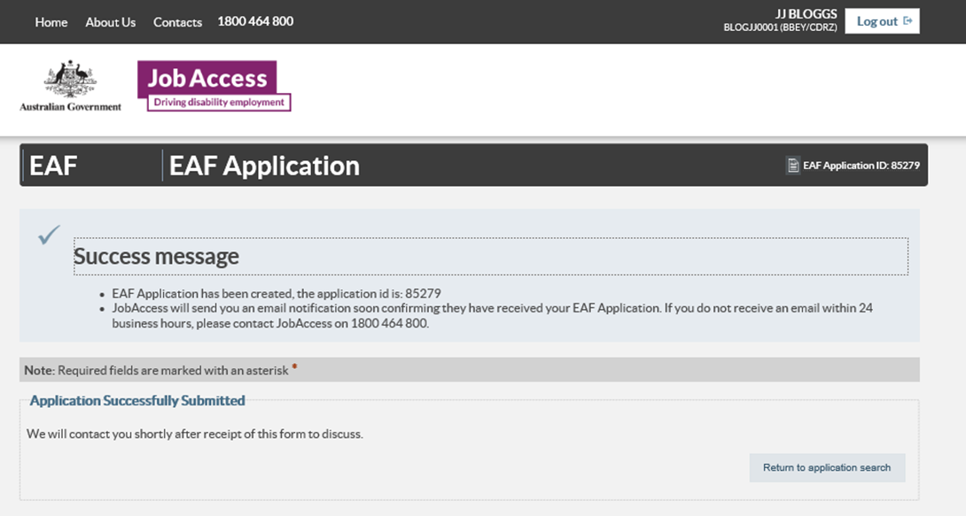
If you need an interpreter, please use The Translating and Interpreting Service (TIS National)
Please do not order or purchase any items prior to receiving written approval, as JobAccess is unable to backdate payments.
The EAF is a reimbursement fund and JobAccess can only reimburse approved applicants after you have supplied proof of purchase. Directions for claiming reimbursement can be found in the EAF Guidelines, as well as the EAF approval letter sent on approval of the application.

