Contact
National Disability Abuse and Neglect Hotline (the Hotline)

The Hotline is a free, independent and confidential service for assistance in reporting abuse and neglect of people with disability.
Anyone can contact the Hotline, including family members, friends, service providers or a person with disability.
The Hotline works with callers to find appropriate ways of dealing with reports of abuse and neglect of people with disability.

Email
Call (toll free)
1800 880 052
hotline@glresolution.au

Visit www.jobaccess.gov.au/complaints-or-report-abuse/make-complaint-report-abuse

National Relay Service
1800 555 677

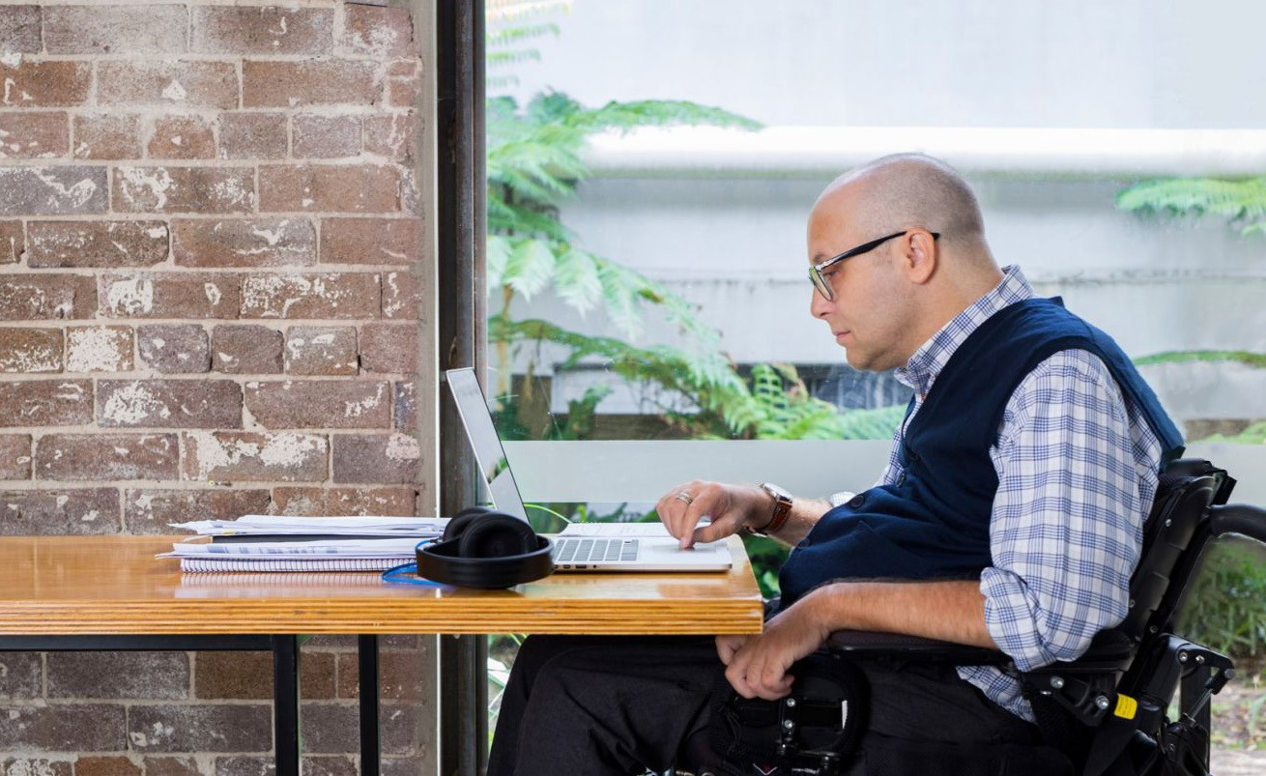



abuse and neglect
It’s OK to talk about
Translating and Interpreting Service
The Hotline is not a crisis service. In case of life-threatening situations, call 000 for attendance by Ambulance, Fire or Police services. If you think a crime has been committed or is being committed, contact your local police.
13 14 50

