Employment Assistance Fund (EAF) online Application - Instructions

  - Online Application – Instructions
This guide provides step-by-step instructions on how to apply for the Employment Assistance Fund (EAF) online via the JobAccess Secure page.
You can apply online if you are seeking funding for Auslan interpreting, workplace modifications/equipment or other supports and you meet the eligibility requirements.
Before you start, please read the EAF Guidelines, which explain:
- who is eligible
- how the application process works
- the evidence required to support your application.
Important: Do not order or purchase any items before receiving written approval, as JobAccess cannot backdate payments for items purchase beforehand.

Contents
Frequently Asked Questions 3
How to begin 4
If you have applied before 5
If you have not applied before 12
Lodging an application 14
Completing the application form 16
Step 6 - Uploading your documents (optional) 20
After you submit your application 23
Accessibility 23

Frequently Asked Questions
You can find answers to common questions here:
- Applying for the Employment Assistance Fund | Job Access
- JobAccess Frequently Asked Questions | Job Access
If you need help, please contact JobAccess:
- 1800 464 800 or
- mailto:jobaccess@genu.org.au.
If you are deaf or hard of hearing or have a speech impairment, you can contact the JobAccess via National Relay Service (NRS).
If you need in interpreter, please use The Translating and Interpreting Service (TIS National).

How to begin
- Go to the JobAccess homepage.
- Select “Secure Login” at the top left-hand of the home page.
- This will display the JobAccess Secure page.

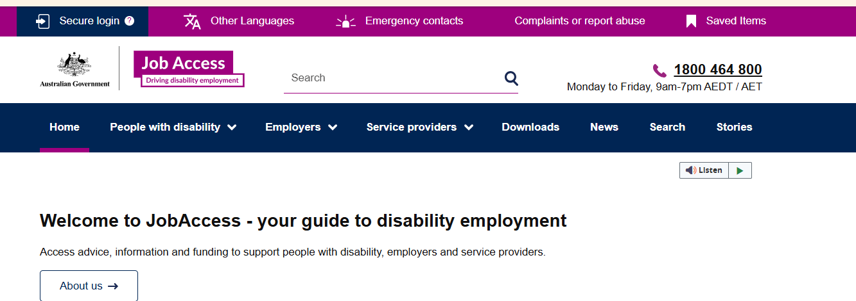
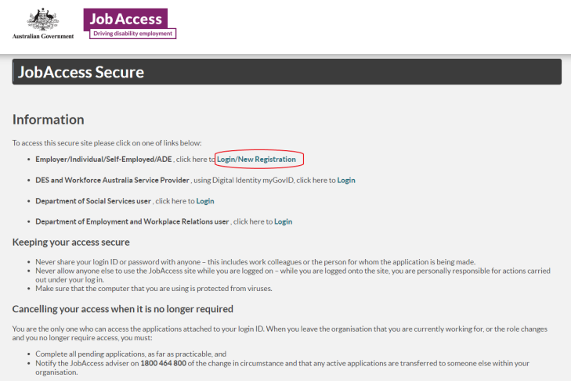

If you have applied before
If you have previously submitted an EAF application using your myGov account, select ‘Sign-in with myGov and log in with your myGov sign in details to access JobAccess secure website.
Once you are logged in, you can:
- Lodge a new EAF application. See Lodging an application within this document for instruction.
- Upload supporting/additional document for your existing EAF application (you can only upload the document after lodging your application). Please note: If your application is more than 12 months old, you will need to lodge a new application.
NOTE: If you receive an error stating that ‘you are not authorised to use this site’, you need to register as a new user. If so, see the New User within this document for instructions.
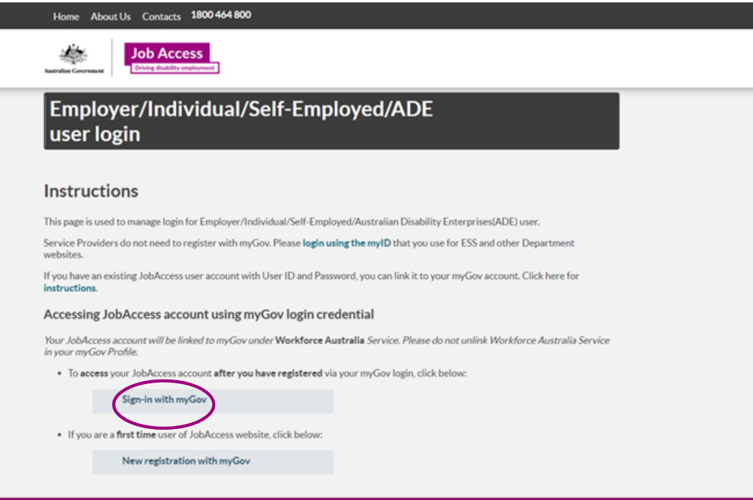

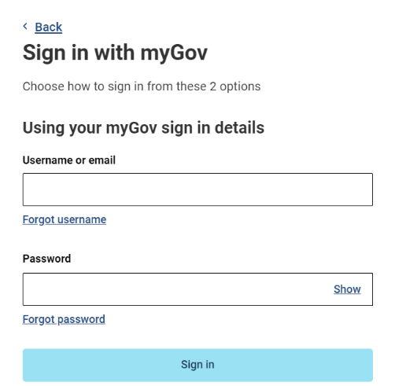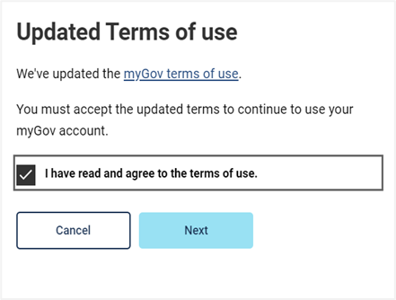

Uploading documents on the JobAccess Website
- Select the first option (Login/New Registration).
- Choose 'Sign in with myGov' and log in using your myGov details.
- Accept Privacy Notice.
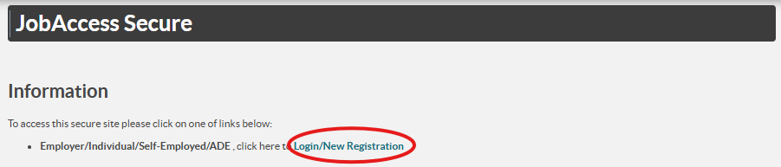
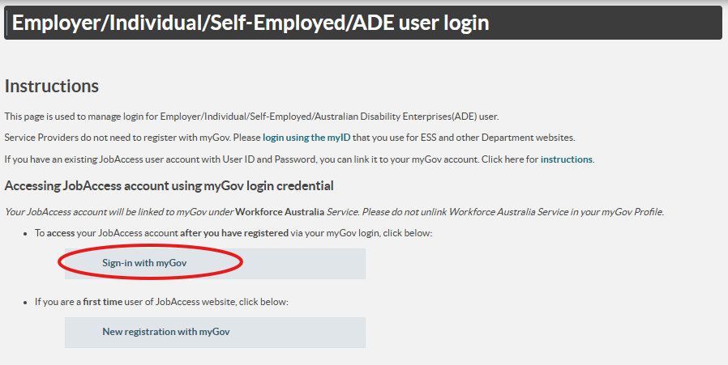
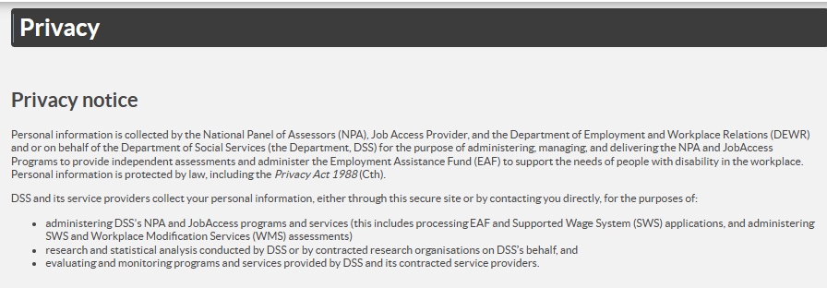
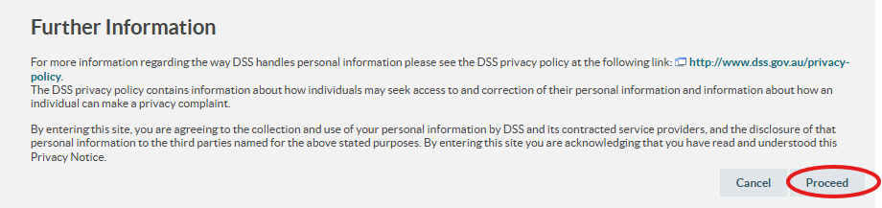

Access your existing application
- On the Welcome homepage, select Access Existing EAF Application
- Enter the EAF ID number of the existing application in the “Search Criteria” box.
  - If you don’t remember it, search using the applicant’s full name
- Click the “Application ID” in the search results tab on the bottom of the left screen. This will take you into the application.
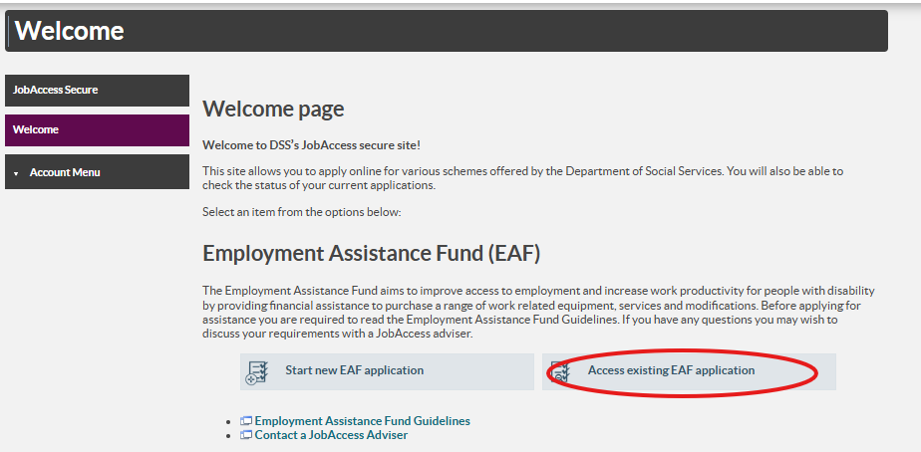

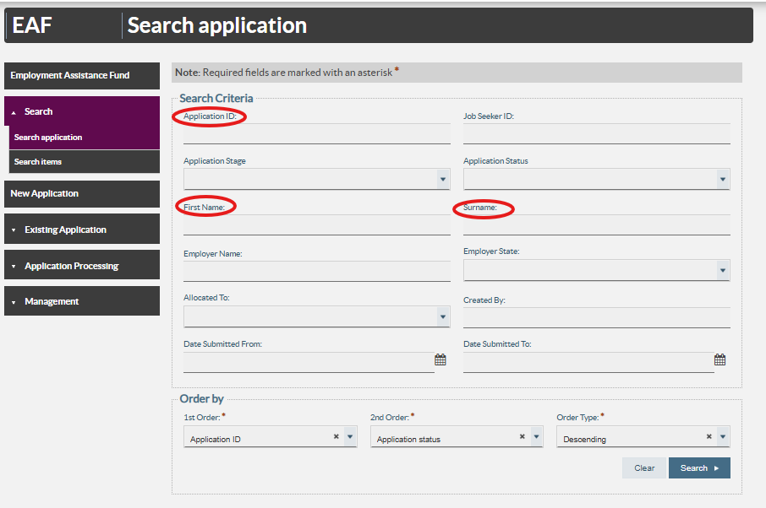
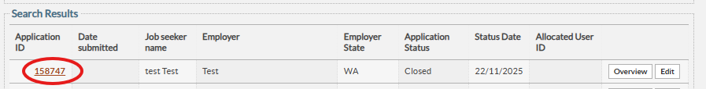

Upload your documents
- On the right-hand side, select ‘Attach/Upload Document’
- In the left-hand menu, select ‘Application Processing’
- In the left-hand menu, select ’Documents/Attachments.’
- Select ‘Upload new document’.
- Upload your file (drag and drop file or choose your file).
- Add a short comment describing the document.
- A success message will appear once the upload is complete.
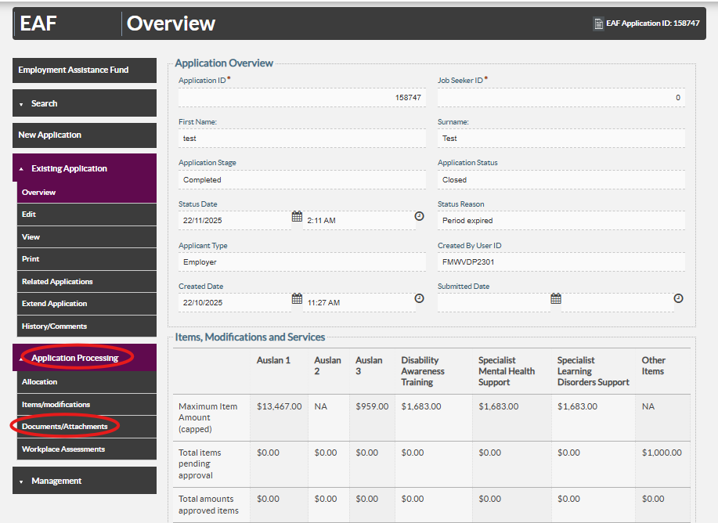
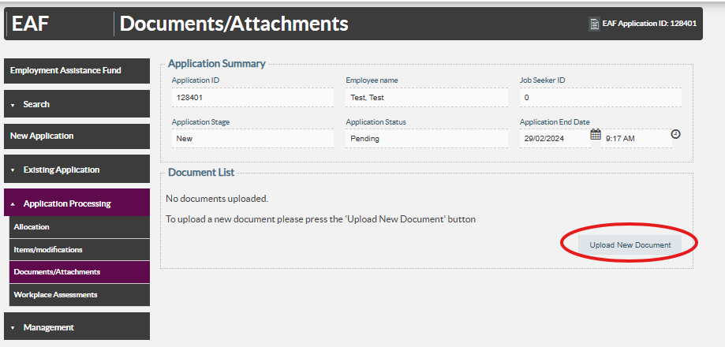

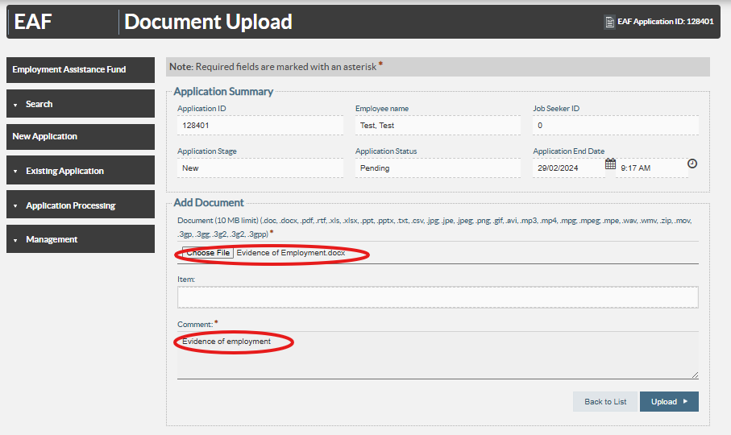
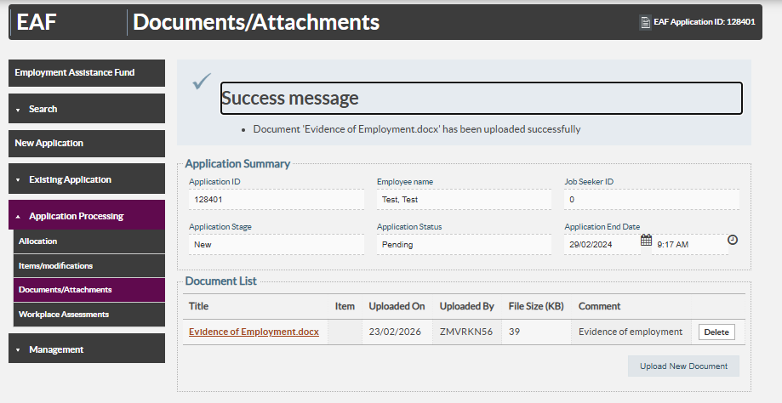
If you uploaded documents after JobAccess made their initial contact to you, email jobaccess@genu.org.au with your application ID number in the subject line so the JobAccess team is aware.
For help, contact the JobAccess team on 1800 464 800.

If you have not applied before
New user instructions
If you have not previously applied for EAF online using your myGov account or need to register again as new user:
- Select ‘New registration with myGov.’
- Select user type from one of the following groups:
  - Australian Disability Enterprises
  - Individual or Employee
  - Self-Employed
  - Employer

- Select ‘Register with myGov.’
- You will be re-directed to the myGov login page.
  - enter your myGov username and password
  - accept the myGov terms of use
- You will then be re-directed to the Department of Employment and Workplace Relations’ eSAM page.
- Accept the ‘User Security Declaration Acceptance’ to complete registration.
- Once complete, select the JobAccess Secure link from this page which will return you to the login screen.
- You can now login using the ‘Sign-in with myGov’ button.

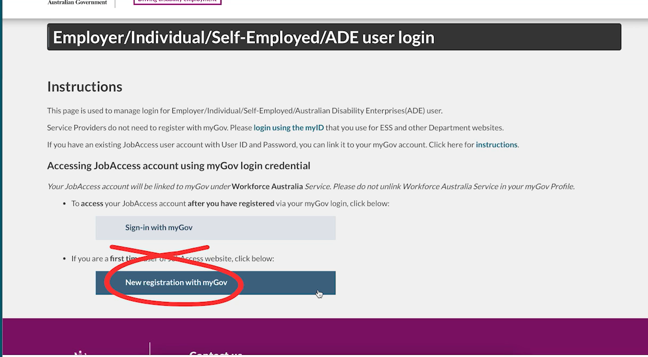
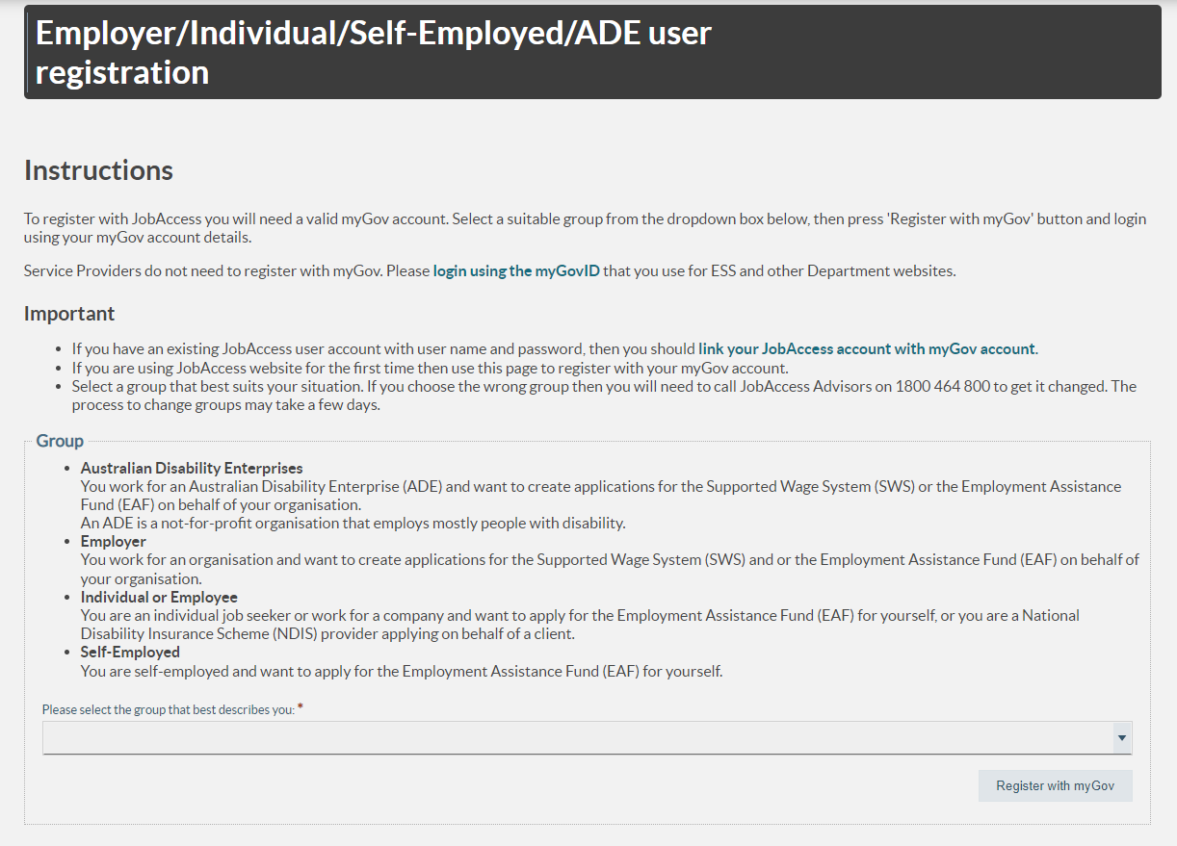
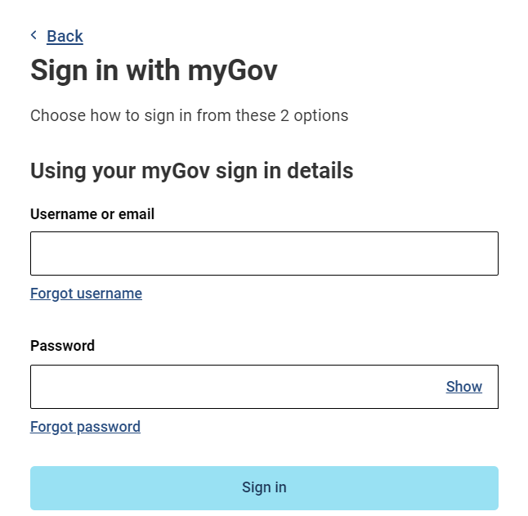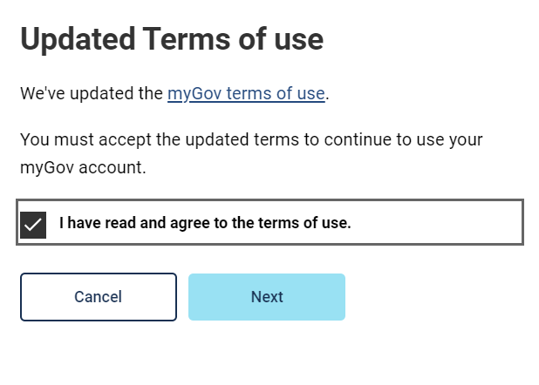
Blue arrow

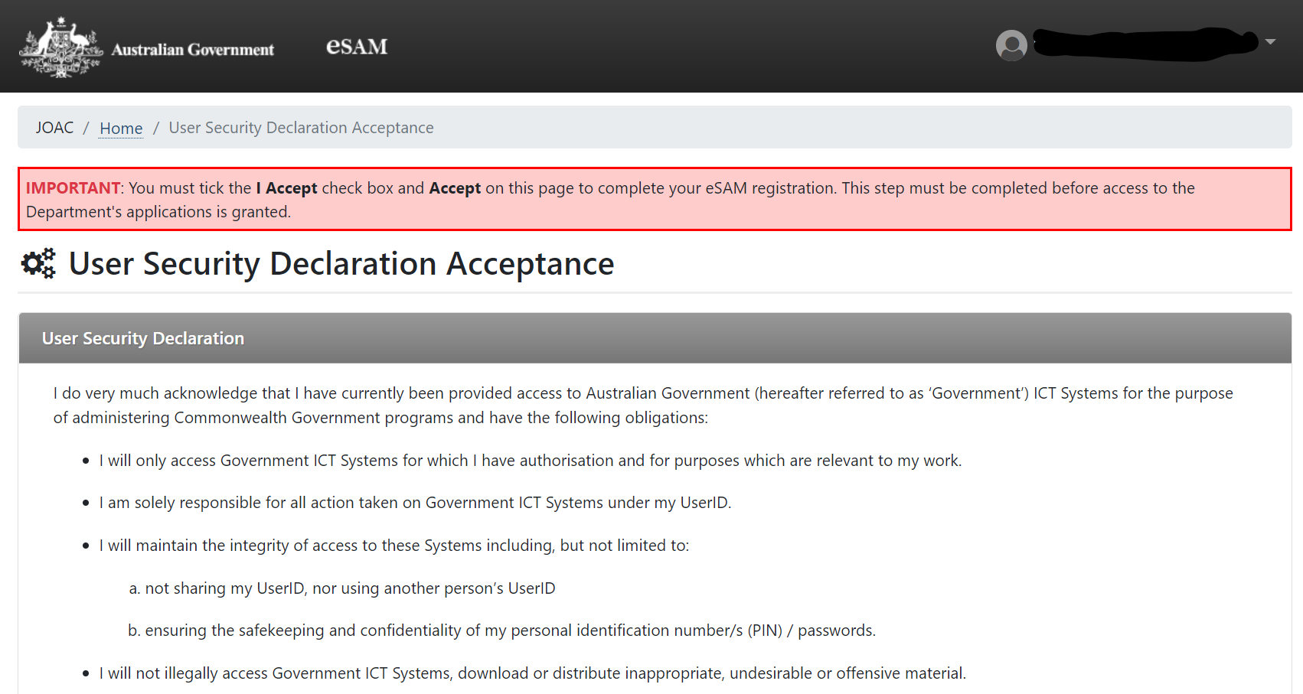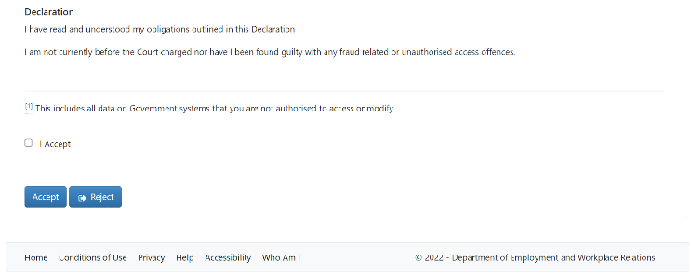

Lodging an application

- Read the ‘Privacy Notice’ and select ‘Proceed’ button to start the application.
- The Welcome Page will display.
- Individuals (self-employed/employees), Employers, ADEs, or Service Providers can lodge an EAF application.
- Select ‘Start New EAF application’.
- Choose who is making the application from the drop-down list and select next at the bottom on the page.
- The sites terms and conditions will display.
- Review the Terms and Conditions, tick the box and submit.

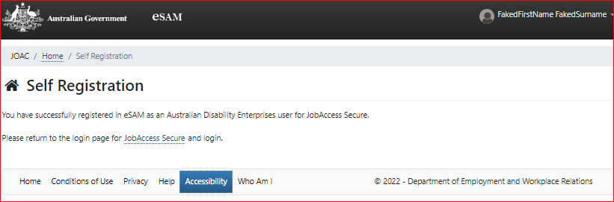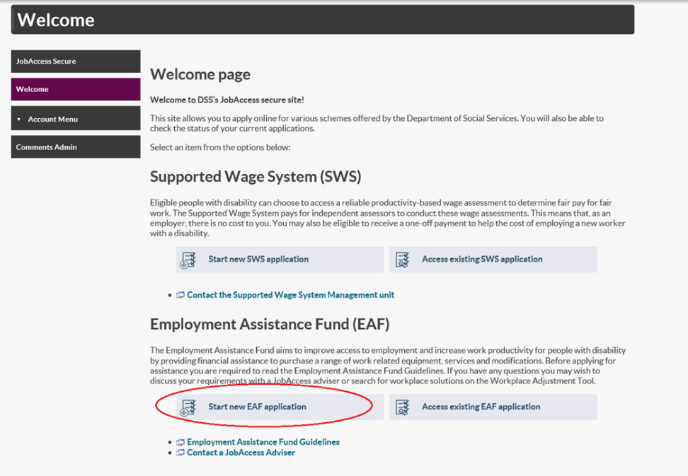

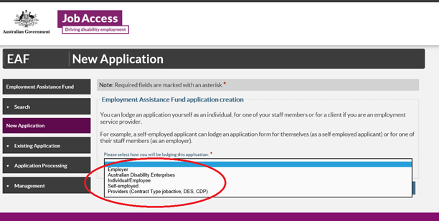

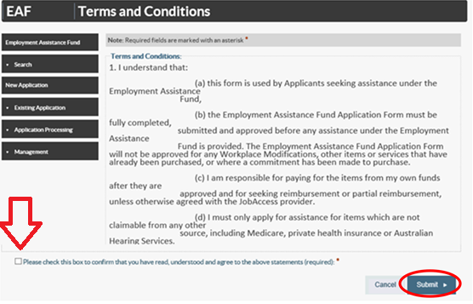

Completing the application form
Note: The online application has five tabs. All mandatory field (marked with an asterisk*) must be completed.
Your EAF Application ID number will display at the top right corner.

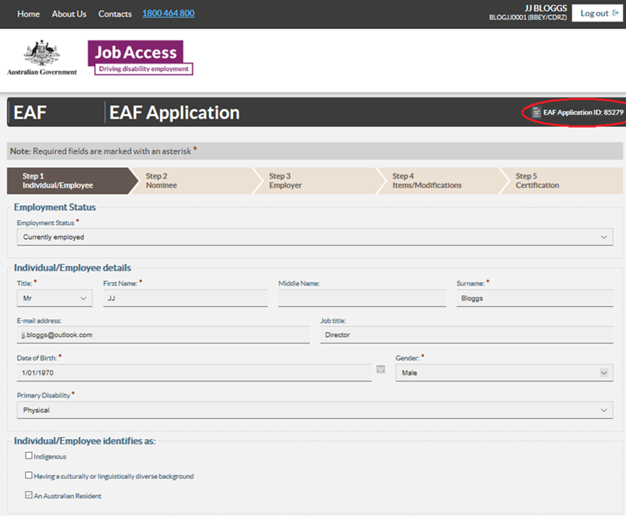

Step 1 – ‘Individual / Employee’.
Enter the employee’s details (full name, contact details address).
If they have a different postal address, untick and put the postal address. If their postal address is the same leave the box selected.

Step 2 – ‘Nominee’. Nominee.
Select ‘Yes’ only if someone is acting on behalf of the employee.
Complete all fields or select ‘No’ to proceed.
NOTE: an employer contact is not considered a nominee, this will be completed at the next step.

Step 3 – ‘Employer’.
Provide employers’ details.
Use www.abr.business.gov.au to look up ABN details.
The employer contact should be a line manager, team leader, or HR representative.
Select ‘Next.’
If you have concerns about what information will be shared with your employer, please call JobAccess on 1800 464 800.

Step 4 – ‘Items / Modification’.
Select ‘Add item.’
Item Type, if not applying for Auslan services or training, select ‘Other’ for Workplace Modifications.
Under ‘description’ type in the description of the item. If unsure enter “to be determined” and go to the next tab.
Under ‘Item Cost’ enter the cost of the item, or if you are unsure enter $0.00.
Under ‘Ownership’ select the owner of the item. The owner is generally always the individual/employee with disability unless the funding is for a building modification or by agreement with all parties).
Under ‘Reimbursement’ select who will be paying for the item, should your application be approved. This is who JobAccess will reimburse the funds to following proof of purchase.
Select ‘Save.’ If you need to add another item, select ‘Add Item.’ If not select ‘Next’ to proceed to Step 5, ‘Certification’.
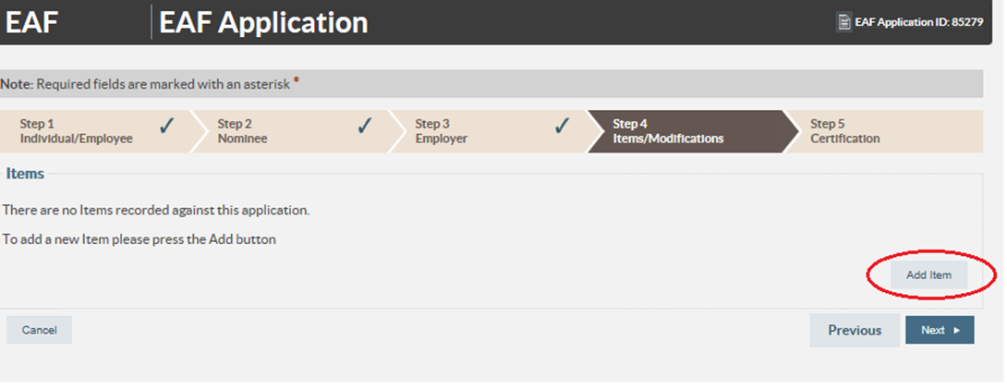
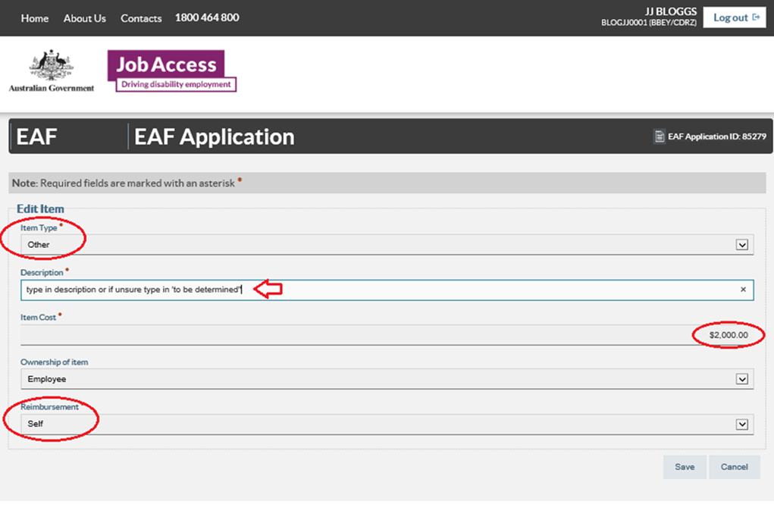

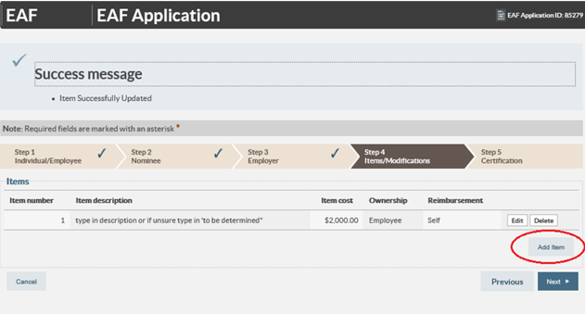

Step 5 - ‘Certification’. Read the certification statements, tick the box, and select ‘submit. Once your application has been successfully submitted, you will see a confirmation message.
If you have your supporting documents available, select “Attach/Upload Document” to upload them to your existing EAF application.
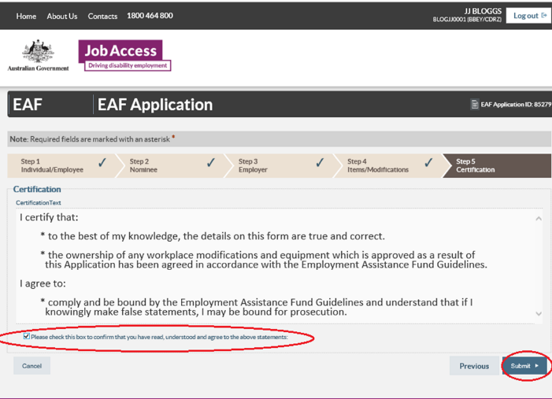

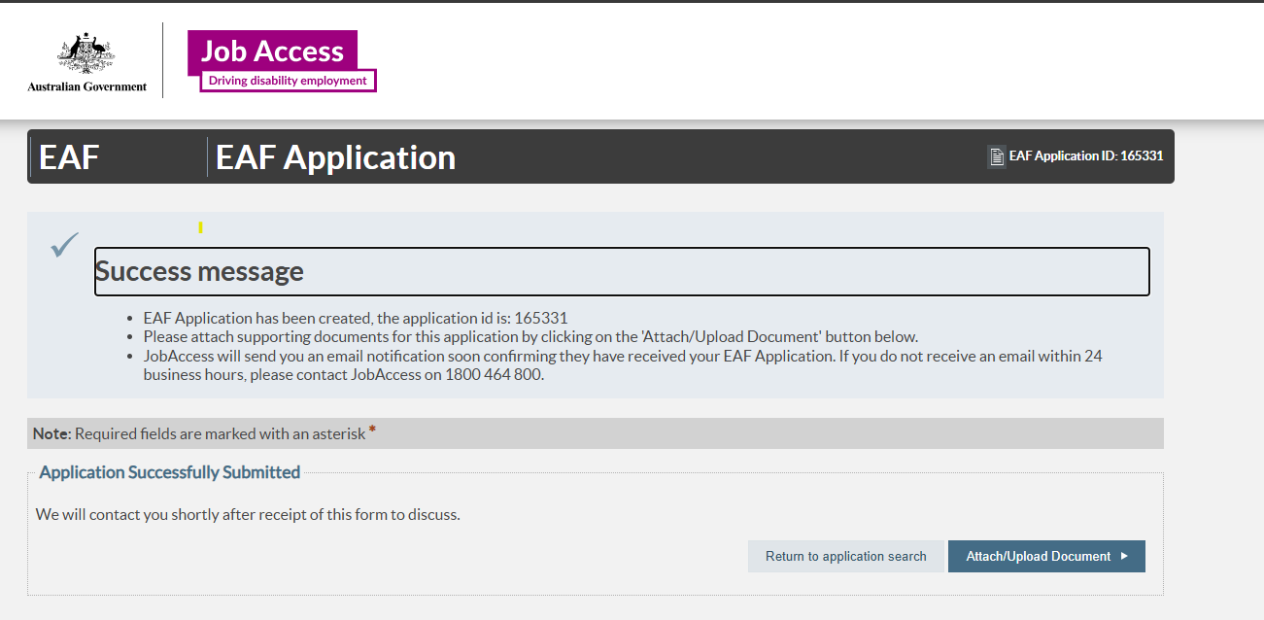

Step 6 - Uploading your documents (optional)
- On the right-hand side, select ‘Attach/Upload Document’
- In the left-hand menu, select ‘Application Processing’
- In the left-hand menu, select ‘Documents/Attachments’
- Select ‘Upload new document’
- Upload your file (drag and drop file or choose your file).
- Add a short comment describing the document.
- A success message will appear once the upload is complete.

If you uploaded documents after JobAccess made their initial contact to you, email jobaccess@genu.org.au with your application ID number in the subject line so the JobAccess team is aware.
For help, contact the JobAccess team on 1800 464 800.

After you submit your application
JobAccess will process the application and contact you as soon as possible. To check on current processing times, call 1800 464 800 or email jobaccess@genu.org.au
If you do not receive a ‘Success message’ with an application ID number, your application did not save correctly.
For help, please contact JobAccess on 1800 464 800 or email jobaccess@genu.org.au.
Thank you for your application.

Accessibility
If you are deaf or have a hearing or speech impairment, you can contact JobAccess via National Relay Service (NRS).
If you need an interpreter, please use the Translating and Interpreting Service (TIS National).
Do not order or purchase items prior to receiving written approval. JobAccess cannot backdate reimbursement.
The EAF is a reimbursement fund; we can only reimburse approved items after receiving valid proof of purchase.
Instructions for claiming reimbursement are included in EAF Guidelines, and in your approval letter.

